Title | Mapper Software Subsystem Design Description
Distribution | Software Archive
Author | Jax Yang | Date | 2014-01-06
Review | See review section | Date | See review section
Approved |  | Date
Remarks

Contents

1 Introduction 4
1.1 Scope 4
1.2 Definitions, acronyms, and abbreviations 4
2 Data Sheet 6
3 Detailed Description 7
3.1 Static Modelling 7
3.2 Dynamic Modelling 8
3.2.1 Diagnosis information mapping 8
3.2.2 HART dynamic variable accessing 9
3.2.3 Get variable percentage for CO/DO 9
3.3 Class Design 9
3.4 Detailed Design 11
3.4.1 Device Variable mapping 11
3.4.1.1 Map List design 11
3.4.1.2 Interface Functions 11
3.4.2 HART dynamic variables Mapping 12
3.4.2.1 Dynamic variable objects 12
3.4.2.2 Dynamic variables Mapping table 13
3.4.3 Device variable manage 14
3.4.4 Diagnosis mapping 15
3.4.4.1 Input Diagnosis simulation mapping 15
3.4.4.2 Diagnosis group mask mapping 18
3.4.4.3 Specific diagnosis mask mapping 18
3.4.4.4 Diagnosis details mapping 19
3.4.5 PV percentage for CO/DO 19
3.5 Design Decisions and Limitations 20
3.5.1 Macro value Sequence 20
3.5.2 Usage of Mapper 20
3.6 Hardware Dependencies 20
3.7 Data Object Description 20
4 References 20
5 Revision History 20
6 Design Review 21
6.1 Decision of the Review: 21
6.2 Check list: 21
6.3 Remarks: 21
6.4 Defects 21
6.5 Changes are proved: 22

List of Figures
Figure 1: Mapper Subsystem Use Case Diagram 4
Please refer Figure 2: Mapper Subsystem Use Case Diagram 7
Figure 2: Context of Mapper subsystem 8
Figure 3: Diagnosis information mapping 8
Figure 4: HART dynamic variable accessing 9
Figure 5: Get variable percentage for CO/DO 9
Figure 6: Mapper Class Diagram 10
Figure 7: Map List 11
Figure 8: HART Dynamic Variables Mapping 14
Figure 9: Temperature management 15
Figure 10: Input diagnosis simulation mapping 16

List of Tables
Table 1: Device variables in Mapper 11
Table 2: HART dynamic variable objects 13
Table 3: Diagnosis simulation mapping objects 17
Table 4: Diagnosis group mask mapping objects 18
Table 5: Diagnosis specific mask mapping objects 18
Table 6: Diagnosis details mapping objects 19

Introduction

Scope
This Document is a representation of analysis, planning, implementation and decision-making. It consists of design information for the subsystem Mapper.

The document is divided into two main parts. Firstly there is the subsystem Data Sheet. This chapter lists important issues from a black-box view. Secondly there is a more detailed design description intended for developers who have to maintain or expand the subsystem.

Besides this document there are other documents that describe the requirements [1], test cases and the complete system the subsystem is used in. Links to those documents can be found at the end of the data sheet and in the references section.
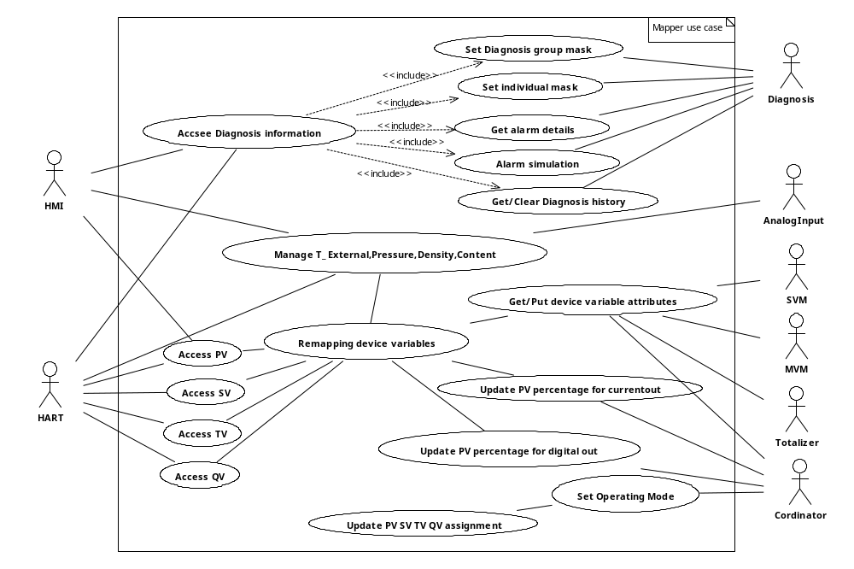
Figure 1: Mapper Subsystem Use Case Diagram

Definitions, acronyms, and abbreviations
Term | Definition
HMIGen | A software tool used to generate the HMI subsystem common source code.
EntryTool | A software tool used to generate the subsystem framework source code.
HART | 2 Wire communication protocol (Highway Addressable Remote Transducer)
Current Out | A subsystem used to output 4~20 mA to send measure result and alarm information if any alarm occurred.
Digital Out | Subsystem used to output digital signal to send measure result and alarm information if any alarm occurred.
HMI | Human Machine Interface for local user access via display and key input.
Diagnostic subsystem | A subsystem responsible for handling error conditions and warnings. Also provides General Alarm data for the Digital Output subsystem
NV subsystem | A subsystem responsible for read / write access and maintenance of non-  volatile memories (in transmitter and sensor).
Qv | Volume flow
Qn | Volume flow under standard condition
Qm | Mass flow
Qp | Energy flow
QvPartial | Partial volume flow
QnParial | Partial volume flow under standard condition
MVM subsystem | Multi-Variable Measurement, mainly mange the Qn,Qm,Qp, QvPartial,QnPartial,
SVM subsystem | Single Variable Measure subsystem used to manage the Qv.
UOM subsystem | Subsystem used to converting units
Electronic Service subsystem | Subsystem used to manage the electronic parts, such as ROM/RAM checking ,board temperature, dip switch etc.
ServicePort subsystem | Subsystem providing communication like HMI & HART for service engineer on HMI connector.
TOT | Subsystem used to totalize the device variable Qv,Qn,Qm,Qp,QvPartial,QnPartial.
Classification | The device variable type from the point of view of HART protocol
Operating Mode | The device work mode
PV | Primary variable define by HART protocol used to dynamic mapping real device variable
SV | Secondary variable define by HART protocol used to dynamic mapping real device variable
TV | Tertiary variable define by HART protocol used to dynamic mapping real device variable
QV | Quaternary variable define by HART protocol used to dynamic mapping real device variable
CO | Current out subsystem
DO | Digital out subsystem

Data Sheet
This chapter gives an overview about all important facts of the subsystem. It can be used by a developer who would like to reuse this subsystem.
Category | Item | Description
Development | Version / Status | 0.1.0
Development | Known Bugs | None
Development | Planned Improvements | None
HW-Platform | Type | M16CR5F363AM
HW-Platform | Clocking | System Clocking — 3.684MHz
SW-Development Environment | Compiler | IAR for M16C, V3.4
SW-Development Environment | Operating System | Segger embOS for M16C version 3.28g
SW-Development Environment | Case / Code-Generation Tool | EntryTool 1.1.3
Required Resources | Operating System | Semaphore: mapperDataSemaphore
Required Resources | HW | None
Required Resources | RAM | 434 Bytes
Required Resources | NVRAM | 62 Bytes
Required Resources | ROM | 15996 Bytes
Required Resources | Execution Time
Required Resources | Special HW | HW independent
Required Resources | Subsystems | - Diagnosis  - MVM  - HART  - Current Out  - HMI  - Coordinator  - Analog Input  - SVM  - Digital Out
Required Resources | Data Objects | - TABENUM8  - SIMPLE_U8  - ACTION  - SIMPLE_U16  - SIMPLE_U32  - FLOAT  - USIGN8  - SIMPLE_FLOAT  - CONST_U8  - UOM_PF  - DEV_RNGFLT  - RANGEFLT  - TABENUM16  - T_DIAGNOSIS_ALARM  - SIMPLE_U32
Standards | Safety | - Mapper is in the safty loop.  - Mapper shall have methods to protect PV assignment.
Standards | Other | None
Documentation | Requirements / Use Cases | Please refer Figure 2: Mapper Subsystem Use Case Diagram
Documentation | Public Interface Description | Please refer Detailed Design
Documentation | Test Specification | Please refer [TP017]Mapper Software Subsystem Test Plan

Detailed Description

Static Modelling
Mapper subsystem bridges the HMI and HART to other subsystems, such as Diagnosis, Analog Input, SVM, MVM, Totalizer and Coordinator. The context diagram of mapper is showed as Figure 2.

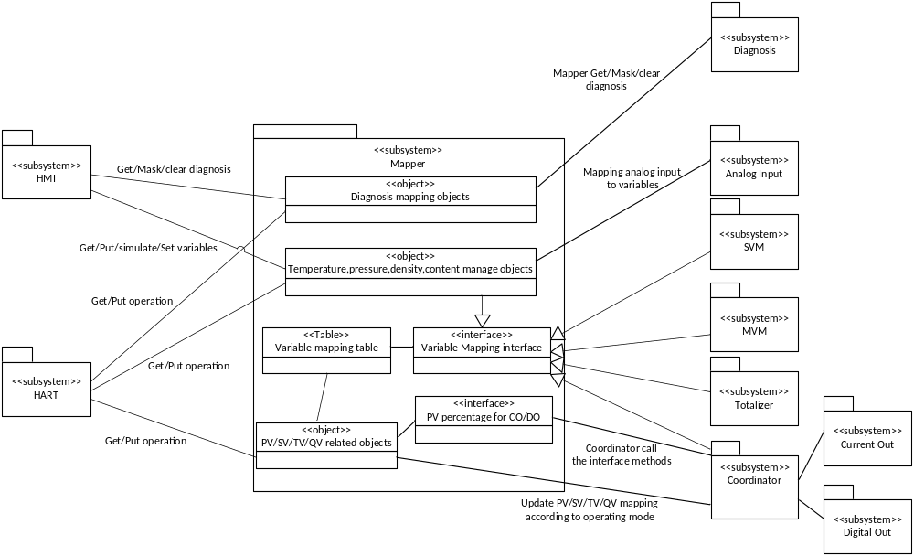

Figure 3: Context of Mapper subsystem

Dynamic Modelling

Diagnosis information mapping
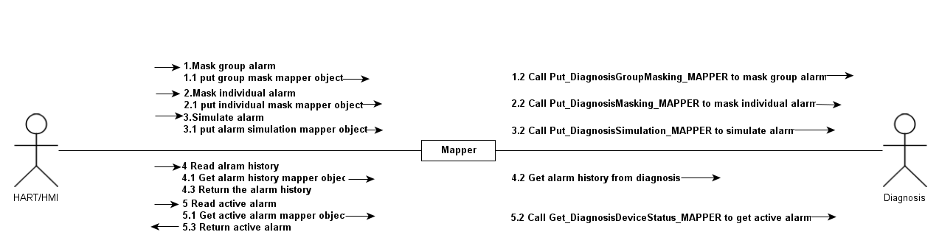
Figure 4: Diagnosis information mapping

Figure 3 shows the diagnosis information mapping between Diagnosis with HMI and HART subsystems. When HART/HMI access the mapper diagnosis objects, Mapper will launch Put/Get operation from diagnosis subsystem to access current diagnosis information and return the information to HART/HMI.

HART dynamic variable accessing

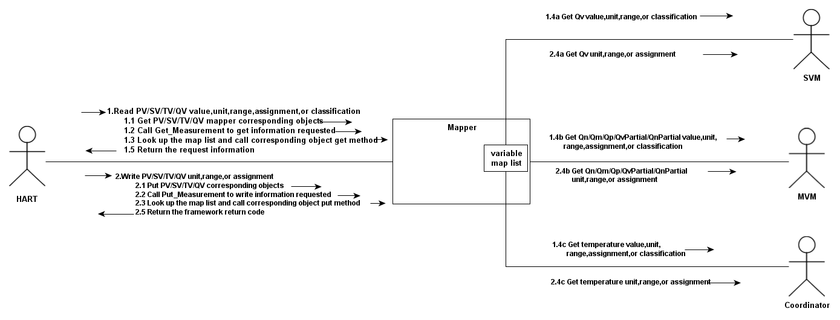
Figure 5: HART dynamic variable accessing
Figure 4 shows HART PV/SV/TV/QV dynamic mapping sequence, HART subsystem calls the Put/Get method when a PV/SV/TV/QV related communication occurred, then mapper will look up the device variable through PV/SV/TV/QV assignment index in the device variable mapping table. If the device variable is mapped to the dynamic variable, then mapper subsystem will Put/Get the device variable information from other target subsystem, like SVM, MVM, Coordinator, etc.

Get variable percentage for CO/DO
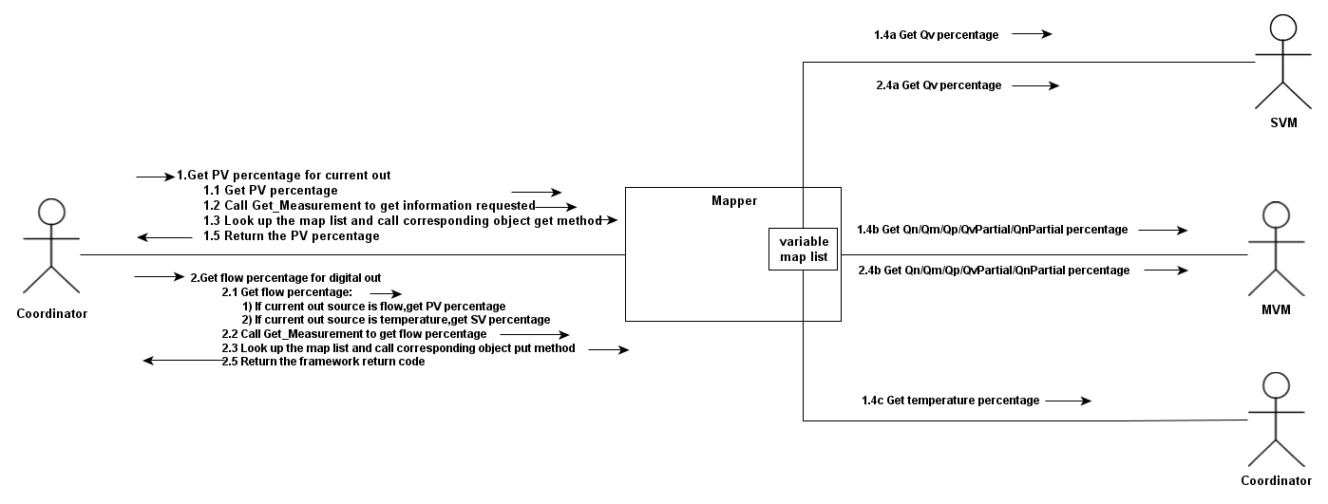
Figure 6: Get variable percentage for CO/DO
Figure 5 shows the sequence of getting variable percentage for Current Out/Digital Out subsystem. The operations are launched by Coordinator.For Digital Out source getting, Coordiantor launched the operation firstly,Mapper will return PV percentage if the Current Out source is flow, SV percentage if the Current Out source is temperature. For Current Out source getting, when Coordinator launch the operation, Mapper will return the PV percentage diretly. When the user select flow as the Current Out source , the flow related variable will be mapped to PV. When temperature is selected as Current Out source, temperature will be mapped to PV.

Class Design

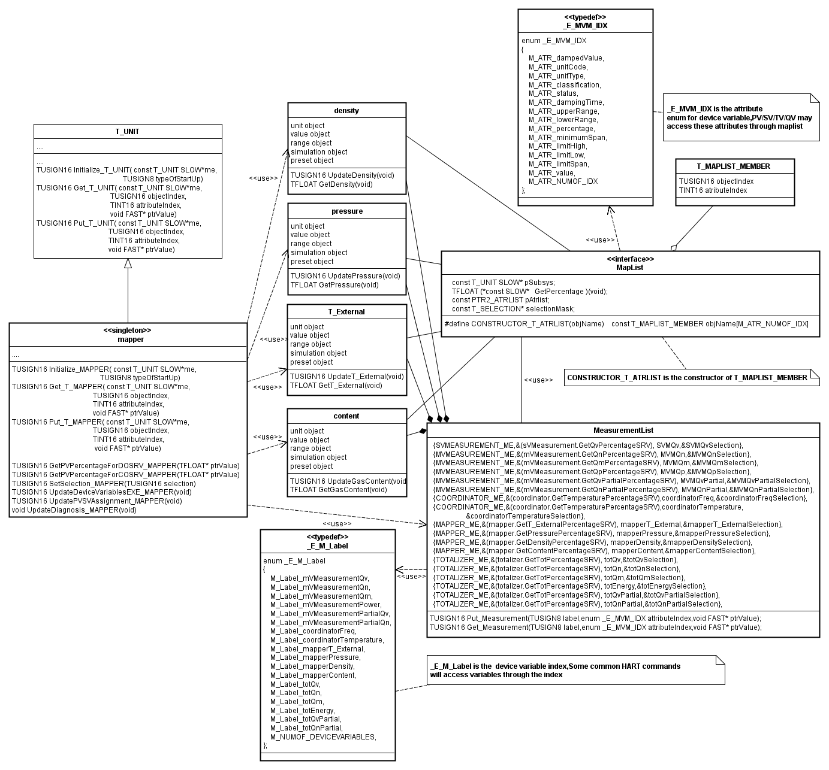
Figure 7: Mapper Class Diagram
Figure 6 shows the class of Mapper subsystem. Maplist is the interface for device variable mapping, other subsystems which manage device variables (such as SVM, MVM etc.) should implement this interface. Mapper will add these objects into the mapping list used to map the device variables.

Detailed Design

Device Variable mapping

Map List design
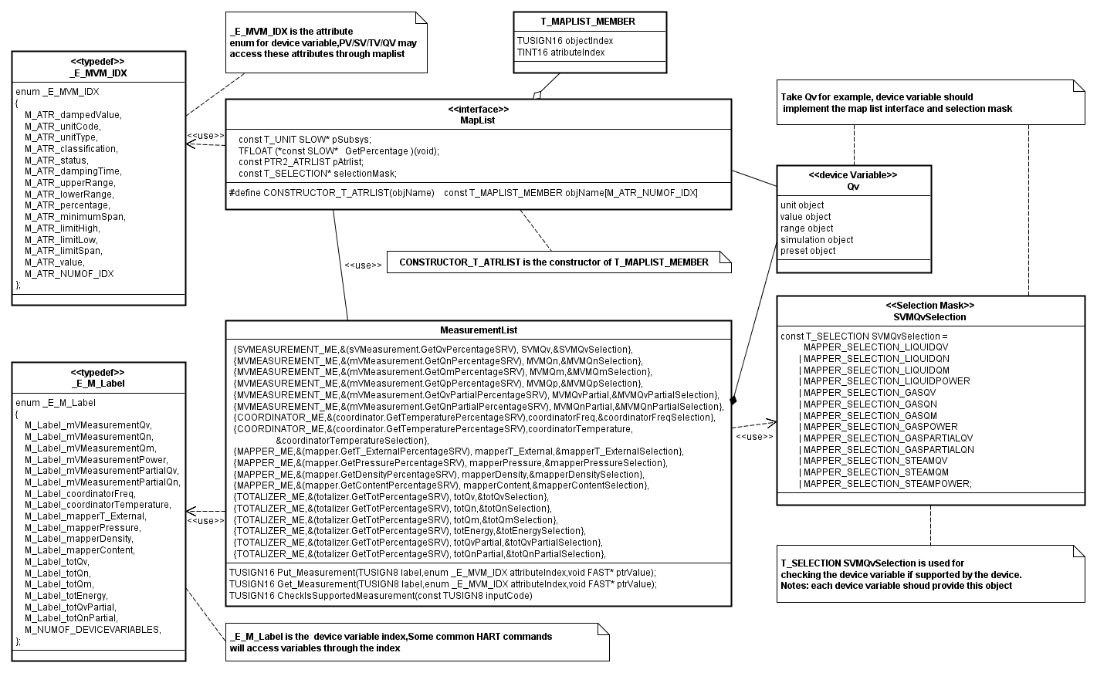
Figure 8: Map List
MeasurementList have 18 device variables,which are managed by SVM,MVM,Coordinator,Mapper,Totalizer.Each device variable should implement variable T_SELECTION mask object according to the requirement . Mapper manage 4 device variables as Table 1.

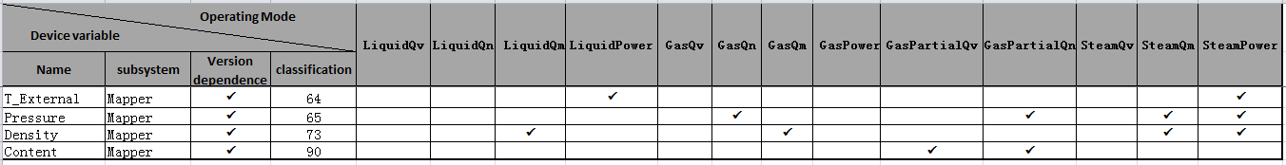
Table 1: Device variables in Mapper

Interface Functions
- Put_Measurement
Description
Mapping the mapper objects put operation with the device variable attributes put operation.
Prototype
TUSIGN16 Put_Measurement(TUSIGN8 label,enum _E_MVM_IDX attributeIndex,void FAST* ptrValue)

Parameter | Description
TUSIGN8 label | Device variable index, valid range (0~17)
enum _E_MVM_IDX attributeIndex | Device variable information index, valid range please refer to _E_MVM_IDX enum.
void FAST* ptrValue | The pointer pointing the put value
Return
Framework return code.

- Get_Measurement
Description
Mapping the mapper objects get operation with the device variable attributes get operation.
Prototype
TUSIGN16 Get_Measurement(TUSIGN8 label,enum _E_MVM_IDX attributeIndex,void FAST* ptrValue)

Parameter | Description
TUSIGN8 label | Device variable index, valid range is 0~17
enum _E_MVM_IDX attributeIndex | Device variable information index, valid range please refer to _E_MVM_IDX enum.
void FAST* ptrValue | The pointer pointing the get value
Return
Framework return code.

- CheckIsSupportedMeasurement
Description
The interface for checking if the device variable is supported by current operating mode.
Prototype
TUSIGN16 CheckIsSupportedMeasurement(const TUSIGN8 inputCode)
Parameter | Description
const TUSIGN8 inputCode | Device variable index, valid range is 0~17
Return
OK. If the device variable is supported by current operating mode.
RULE_VIOLATION_ERR. If the device variable is not supported by current operating mode

HART dynamic variables Mapping

Dynamic variable objects
HART defined the dynamic variable need these information fields:
- Value damped
- Unit code
- Unit type
- Classification
- Status
- Damping time
- Upper range
- Lower range
- Percentage
- Range span
- Limit high range
- Limit low range
- Value before damping
So the objects as Table 2 have been defined to meet the requirement:
Object | T_DATA_OBJECT | Data Class | Storage type | Description
PV | FLOAT | DYNAMIC | RAM | Dynamic variable PV value
SV | FLOAT | DYNAMIC | RAM | Dynamic variable SV value
TV | FLOAT | DYNAMIC | RAM | Dynamic variable TV value
QV | FLOAT | DYNAMIC | RAM | Dynamic variable QV value
PV_Unit | USIGN8 | DYNAMIC | RAM | Dynamic variable PV unit
SV_Unit | USIGN8 | DYNAMIC | RAM | Dynamic variable SV unit
TV_Unit | USIGN8 | DYNAMIC | RAM | Dynamic variable TV unit
QV_Unit | USIGN8 | DYNAMIC | RAM | Dynamic variable QV unit
PV_RangeUnit | USIGN8 | DYNAMIC | RAM | Dynamic variable PV range unit
SV_RangeUnit | USIGN8 | DYNAMIC | RAM | Dynamic variable SV range unit
TV_RangeUnit | USIGN8 | DYNAMIC | RAM | Dynamic variable TV range unit
QV_RangeUnit | USIGN8 | DYNAMIC | RAM | Dynamic variable QV range unit
PV_UpperRange | FLOAT | DYNAMIC | RAM | Dynamic variable PV upper range
SV_UpperRange | FLOAT | DYNAMIC | RAM | Dynamic variable SV upper range
TV_UpperRange | FLOAT | DYNAMIC | RAM | Dynamic variable TV upper range
QV_UpperRange | FLOAT | DYNAMIC | RAM | Dynamic variable QV upper range
PV_LowerRange | FLOAT | DYNAMIC | RAM | Dynamic variable PV lower range
SV_LowerRange | FLOAT | DYNAMIC | RAM | Dynamic variable SV lower range
TV_LowerRange | FLOAT | DYNAMIC | RAM | Dynamic variable TV lower range
QV_LowerRange | FLOAT | DYNAMIC | RAM | Dynamic variable QV lower range
PV_Classification | USIGN8 | DYNAMIC | RAM | Dynamic variable PV classification
SV_Classification | USIGN8 | DYNAMIC | RAM | Dynamic variable SV classification
TV_Classification | USIGN8 | DYNAMIC | RAM | Dynamic variable TV classification
QV_Classification | USIGN8 | DYNAMIC | RAM | Dynamic variable QV classification
PV_Status | USIGN8 | DYNAMIC | RAM | Dynamic variable PV status
SV_Status | USIGN8 | DYNAMIC | RAM | Dynamic variable SV status
TV_Status | USIGN8 | DYNAMIC | RAM | Dynamic variable TV status
QV_Status | USIGN8 | DYNAMIC | RAM | Dynamic variable QV status
PV_TFCode | TABENUM8 | DYNAMIC | RAM | Dynamic variable PV TF flag
PV_ACFlag | TABENUM8 | DYNAMIC | RAM | Dynamic variable AC status
PVSensorLimitHigh | SIMPLE_FLOAT | DYNAMIC | RAM | PV sensor limit high
PVSensorLimitLow | SIMPLE_FLOAT | DYNAMIC | RAM | PV sensor limit low
PVSensorLimitUnitcode | SIMPLE_U8 | DYNAMIC | RAM | PV sensor limit unit code
PVSensorminimumSpan | SIMPLE_FLOAT | DYNAMIC | RAM | PV sensor minimum span
PVPercent_Unit | CONST_U8 | CONSTANT | ROM | PV percent unit
PVPercent_Range | FLOAT | DYNAMIC | RAM | PV percent range
PVPercent_Classifiction | CONST_U8 | CONSTANT | ROM | PV percent calssification
PV_DampingTime | SIMPLE_FLOAT | DYNAMIC | RAM | PV damping time
Table 2: HART dynamic variable objects

Dynamic variables Mapping table

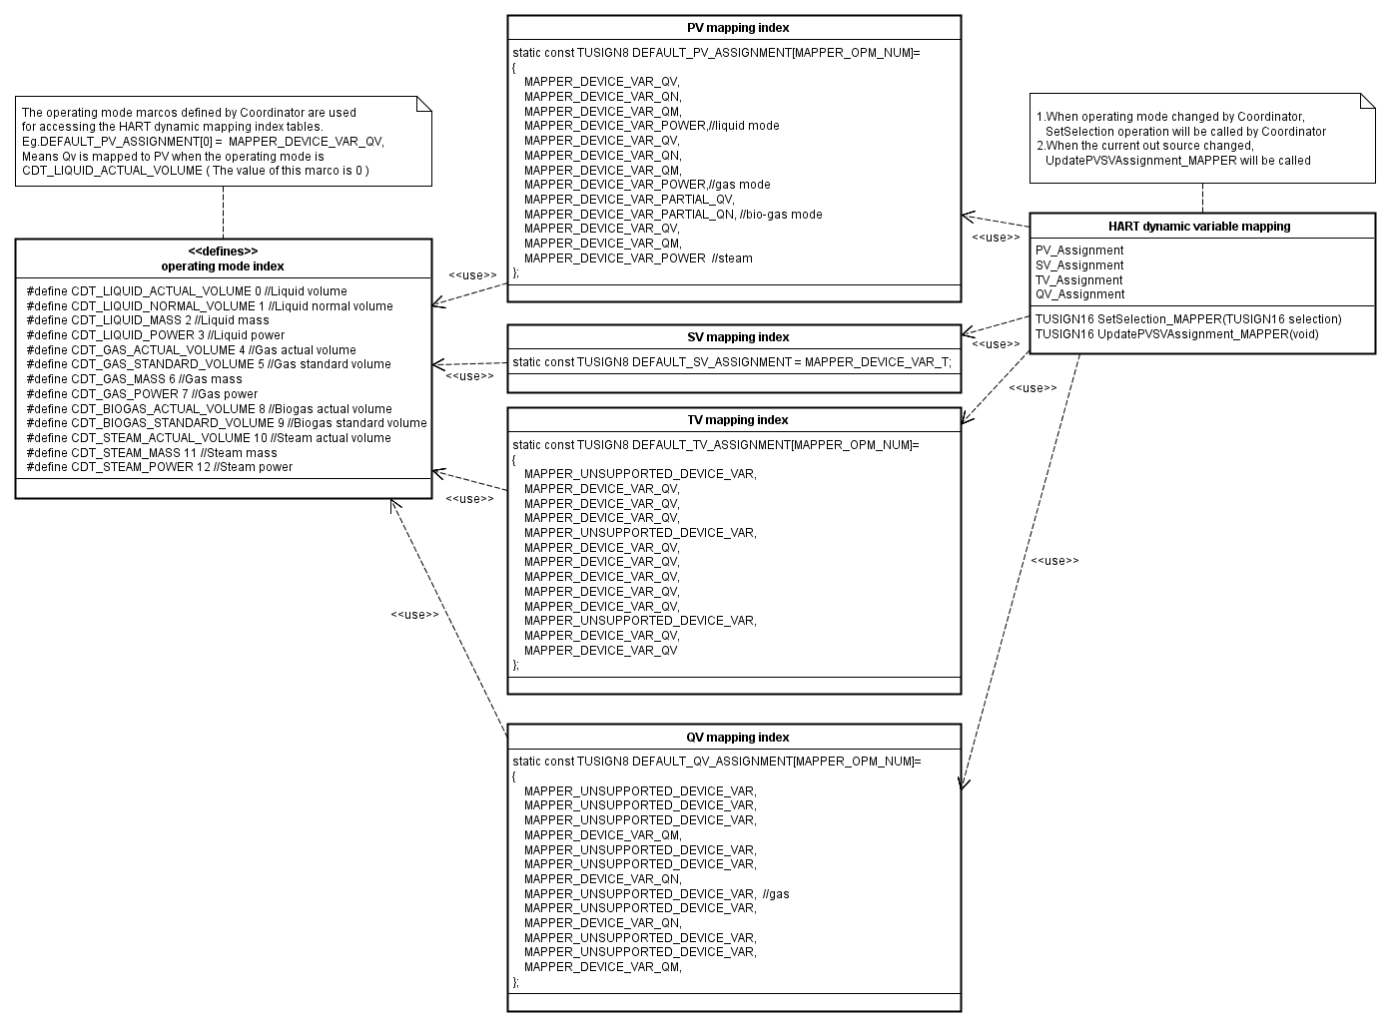
Figure 9: HART Dynamic Variables Mapping
There are four assignment index tables reside in ROM used for HART dynamic mapping, the operating mode is the index for the 4 tables. When the operating mode is changed, the SetSelection_MAPPER(TUSIGN16 selection) should be called.

Device variable manage

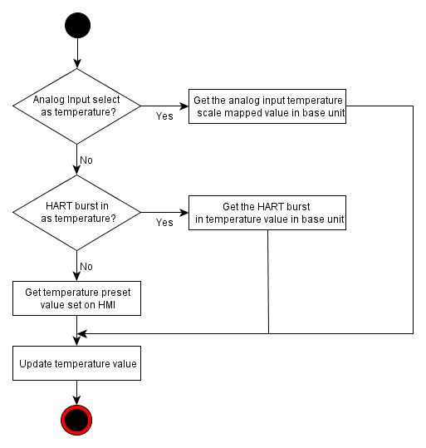
Figure 10: Temperature management
Figure 9 shows the device variable external temperature management. Temperature has 3 value sources, the Analog Input have the highest priority level, HART burst in have less level. The default input channel is HMI preset.
The other three variables Pressure, Density, Content management have the similar processing logic.
TUSIGN16 UpdateDeviceVariablesEXE_MAPPER(void) is the interface for Coordinator to update the 4 device variables. This routine manages the 4 device variables (external temperature, pressure, density, and content). It should be called periodically, so the information updating rate depends on the calling cycle.

Diagnosis mapping

Input Diagnosis simulation mapping

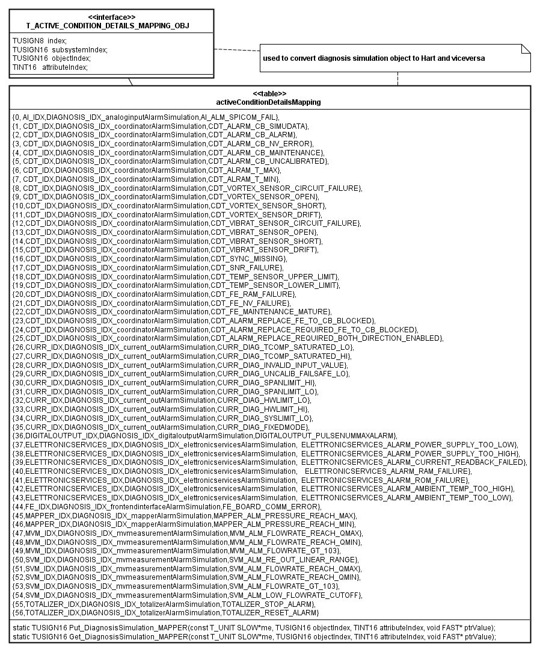
Figure 11: Input diagnosis simulation mapping

This table used to map the object diagnosisSimulation with the real input alarm simulation object.

- Objects
Object | T_DATA_OBJECT | Data Class | Storage type | Description
diagSimulationStatus | TABENUM8 | DYNAMIC | RAM | HMI set Diagnosis simulation status
diagSimulationType | TABENUM8 | DYNAMIC | RAM | Diagnosis simulation type
diagnosisSimulation | SIMPLE_U8 | DYNAMIC | RAM | Diagnosis simulation
Table 3: Diagnosis simulation mapping objects

There are 2 operations for object diagnosisSimulation:
- Put_DiagnosisSimulation_MAPPER
Description
Simulate a definitive input alarm to subsystem which maintained the alarm. It’s a private method for mapper.
Prototype
static TUSIGN16 Put_DiagnosisSimulation_MAPPER(const T_UNIT SLOW*me, TUSIGN16 objectIndex, TINT16 attributeIndex, void FAST* ptrValue)

Parameter | Description
const T_UNIT SLOW*me | Pointer of mapper subsystem, should be MAPPER_ME
TUSIGN16 objectIndex | Object index
TINT16 attributeIndex | Object attribute index
void FAST* ptrValue | The pointer pointing the put value
Return
Framework return code.

- Get_DiagnosisSimulation_MAPPER
Description
Get a definitive input alarm from subsystem which maintained the alarm.
Prototype
static TUSIGN16 Get_DiagnosisSimulation_MAPPER(const T_UNIT SLOW*me, TUSIGN16 objectIndex, TINT16 attributeIndex, void FAST* ptrValue)
Parameter | Description
const T_UNIT SLOW*me | Pointer of mapper subsystem, should be MAPPER_ME
TUSIGN16 objectIndex | Object index
TINT16 attributeIndex | Object attribute index
void FAST* ptrValue | The pointer pointing the get value
Return
Framework return code.

For diagSimulationType, Put_DiagnosisSimulationType use to put the diagnosis simulation type to diagnosis subsystem.
- Put_DiagnosisSimulationType
Description
Get a definitive input alarm from subsystem which maintained the alarm.
Prototype
TUSIGN16 Put_DiagnosisSimulationType(void FAST* ptrValue)
Parameter | Description
void FAST* ptrValue | The pointer pointing the put value
Return
Framework return code.

Diagnosis group mask mapping

- Interface objects
Object | T_DATA_OBJECT | Data Class | Storage type | Description
diagFunCheckMask | TABENUM8 | STATIC_FREQUENT_CONSTANT_DEFAULT | NV | Function check group mask
diagOffSpecMask | TABENUM8 | STATIC_FREQUENT_CONSTANT_DEFAULT | NV | Off specific group mask
diagMaintainMask | TABENUM8 | STATIC_FREQUENT_CONSTANT_DEFAULT | NV | Maintenance group mask
Table 4: Diagnosis group mask mapping objects

The Get_DiagnosisMasking_MAPPER used to map the 3 objects to diagnosis related objects
- Get_DiagnosisMasking_MAPPER
Description
Get the masking information.
Prototype
static TUSIGN16 Get_DiagnosisMasking_MAPPER(const T_UNIT SLOW*me, TUSIGN16 objectIndex, TINT16 attributeIndex, void FAST* ptrValue)
Parameter | Description
const T_UNIT SLOW*me | Should be MAPPER_ME
TUSIGN16 objectIndex | Object index
TINT16 attributeIndex | Attribute index
void FAST* ptrValue | The pointer pointing the get value
Return
Framework return code.

Specific diagnosis mask mapping

- Objects
Object | T_DATA_OBJECT | Data Class | Storage type | Description
diagMinFlowMask | TABENUM8 | STATIC_FREQUENT_CONSTANT_DEFAULT | NV | Min flow mask
diagMaxFlowMask | TABENUM8 | STATIC_FREQUENT_CONSTANT_DEFAULT | NV | Max flow mask
diagFlow103Mask | TABENUM8 | STATIC_FREQUENT_CONSTANT_DEFAULT | NV | Flow over 103% of maximum mask
diagTSensorOffSpecMask | TABENUM8 | STATIC_FREQUENT_CONSTANT_DEFAULT | NV | Temperature sensor off specification mask
diagTxSensorOffSpecMask | TABENUM8 | STATIC_FREQUENT_CONSTANT_DEFAULT | NV | Transmitter Tx sensor off specification mask
diagTSensorFailMask | TABENUM8 | STATIC_FREQUENT_CONSTANT_DEFAULT | NV | T sensor fail mask
diagLowCutoffMask | TABENUM8 | STATIC_FREQUENT_CONSTANT_DEFAULT | NV | Low flow cut off mask
Table 5: Diagnosis specific mask mapping objects

There are 3 operations for mapping the mask mapper objects with the actual diagnosis.
- Put_DiagnosisMasking_MAPPER
Description
Perform mask writing.
Prototype
static TUSIGN16 Put_DiagnosisMasking_MAPPER(const T_UNIT SLOW*me, TUSIGN16 objectIndex, TINT16 attributeIndex, void FAST* ptrValue)
Parameter | Description
const T_UNIT SLOW*me | Should be MAPPER_ME
TUSIGN16 objectIndex | Object index
TINT16 attributeIndex | Attribute index
void FAST* ptrValue | The pointer pointing the put value
Return
Framework return code.

- Put_DiagnosisGroupMasking_MAPPER
Description
Perform group mask writing.
Prototype
static TUSIGN16 Put_DiagnosisGroupMasking_MAPPER(TUSIGN8 Classification,void FAST* ptrValue)
Parameter | Description
TUSIGN8 Classification | The group classification need to be masked.
void FAST* ptrValue | The pointer pointing the put value
Return
Framework return code.

Diagnosis details mapping
- Objects
Object | T_DATA  _OBJECT | Data Class | Storage type | Description
diagDeviceStatus | SIMPLE_U8 | DYNAMIC | RAM | Diagnosis device status
diagnosisHighCondition | SIMPLE_U8 | DYNAMIC | RAM | Diagnosis high condition
diagnosisHighClass | SIMPLE_U8 | DYNAMIC | RAM | Diagnosis high class
diagnosisHighGroup | SIMPLE_U8 | DYNAMIC | RAM | Diagnosis high group
diagHistory | SIMPLE_U8 | DYNAMIC | RAM | Diagnosis history
diagnosisConditionNumber | SIMPLE_U8 | Unprotected | RAM | Diagnosis condition number
diagnosisConditionDetailsClass | SIMPLE_U8 | Unprotected | RAM | Diagnosis condition details class
diagnosisConditionDetailsGroup | SIMPLE_U8 | Unprotected | RAM | Diagnosis condition details group
diagnosisConditionDetailsPriority | SIMPLE_U8 | Unprotected | RAM | Diagnosis priority condition
diagnosisConditionDetailsAlarmCounter | SIMPLE_U16 | Unprotected | RAM | Diagnosis alarm counter condition
diagnosisConditionDetailsAlarmTimeCounterDay | SIMPLE_U16 | Unprotected | RAM | Diagnosis alarm day
diagnosisConditionDetailsAlarmTimeCounterMsec | SIMPLE_U32 | Unprotected | RAM | Diagnosis alarm mill second
diagnosisConditionDetailsTimeStampLastAlarmDay | SIMPLE_U16 | Unprotected | RAM | Diagnosis last alarm day
diagnosisConditionDetailsTimeStampLastAlarmMsec | SIMPLE_U32 | Unprotected | RAM | Diagnosis last alarm mill second
diagnosisConditionDetailsCodes | SIMPLE_U8 | Unprotected | RAM | Diagnosis condition details code
diagnosisCounter | SIMPLE_U32 | DYNAMIC | RAM | Diagnosis counter
Table 6: Diagnosis details mapping objects
HART connect these objects to access the diagnosis detail information, including the time stamp when a definitive alarm occured,class, group, priorty etc. For details,please refer to the table above.

PV percentage for CO/DO
- GetPVPercentageForDOSRV_MAPPER
Description
Get PV percentage for digital output.
Prototype
TUSIGN16 GetPVPercentageForDOSRV_MAPPER(TFLOAT* ptrValue)

Parameter | Description
void FAST* ptrValue | The pointer pointing the return percentage value
Return
Framework return code.

- GetPVPercentageForCOSRV_MAPPER
Description
Get PV percentage for current output.
Prototype
TUSIGN16 GetPVPercentageForDOSRV_MAPPER(TFLOAT* ptrValue)

Parameter | Description
void FAST* ptrValue | The pointer pointing the return percentage value
Return
Framework return code.

Design Decisions and Limitations

Macro value Sequence

In EntryTool.exe, the MACRO definitions should be listed increasingly by its value; otherwise the HMI can’t display their value.

Usage of Mapper

Because Diagnosis is not generated by EntryTool, so HMI/HART could not get the objet value directly. So for these requirements, Diagnosis objects added in Mapper for HMI/HART to connect, and Mapper do the get/put action to diagnosis.

Hardware Dependencies
none

Data Object Description
Please refer to the links below:
- Table 2 : HART dynamic variable objects
- Table 3 : Diagnosis simulation mapping objects
- Table 4: diagnosis group mask mapping objects
- Table 5: diagnosis speicific mask mapping objects
- Table 6: diagnosis details mapping objects

References
Ref. | Document
[1] | RS016-Mapper Software Subsystem Requirements Specification of VT5
[2] | Universal Command Specification ,HCF_SPEC-127, Revision 7.1
[3] | Common Practice Command Specification, HCF_SPEC-151, Revision 9.1

Revision History
Rev. | Description of Version/Changes | Primary Author(s) | Date
0.1 | Initial revision. | Jax Yang | 2013-04-18
0.2 | Modified the document according to the review result of initial revision. | Jax Yang | 2013-04-28
0.3 | Update embos version in section 2. | Jax Yang | 2014-01-06

Design Review
Dept. | Name
R&D ShangHai | Merrick Huang, Lawrence Shi, Zuochen Wang, Spring Zhou, Tongkun Liu, Vincent Liu | 2013-04-26 rev0.1

Dept. | Name
R&D ShangHai | Spring Zhou  Zuochen Wang | 2013-04-29 rev0.2

Dept. | Name
R&D ShangHai | Merrick Huang | 2014-01-06 rev0.3

Decision of the Review:
 | Decision | next steps
 | Inspection passed without restrictions | Phase finished
x | Inspection passed with restrictions | some changes must be done
 | Inspection not passed | Inspection must be repeated

Check list:
 |  | yes | no
1. | Is the software architecture distinct and documented? | Y
2. | Fit the modules together? | Y
3. | Are complex algorithms/procedures explained? | Y
4. | Is a strategy for error handling designated? | Y
5. | Is the configuration management system well prepared? | Y
6. | Are all open issues transferred to the defects table? | Y

Remarks:

Defects
No. | Checkpoint | Description | Major defect | Done Date
1 |  | Change the use case diagram:  - Get PV percentage for current out -> Update PV percentage for current out  - Get PV percentage for digital out -> Update PV percentage for digital out | N | 2013-04-26
2 |  | Section 2. Data sheet  - The required resources need to be specified:  - RAM  - NVRAM  - ROM  - Subsystem “Digital out” don’t need | N | 2013-04-26
3 |  | 3.1 static modelling :  “subsystem bridge” shall be “subsystem bridges” | N | 2013-04-26
4 |  | 3.2.1 “Diagnosis information mapping” shall be “Access diagnosis information” | N | 2013-04-26
5 |  | Figure 3,4,5 need to de redraw ,the sequence collaboration diagram would be better | N | 2013-04-26
6 |  | Section 3.5.1 need to be deleted. | N | 2013-04-26
7 |  | Figure 9, “temperature management” shall be “temperature update” | N | 2013-04-26
8 |  | “Interface objects” shall be “objects” | N | 2013-04-26
9 |  | Modify the emboss version in datasheet section | N | 2014-01-06

Changes are proved:
The Reviewer confirms that all changes are done:
Proved Rev: | Date: | Reviewer:
0.2 | 2013-04-29 | Spring Zhou  Zuochen Wang
0.3 | 2014-01-06 | Merrick Huang

